TIPS & TRICKS FOR RNA ISOLATION
RNA extraction is a notoriously difficult endeavor. Common challenges include RNA degradation, low yield and/or purity, and DNA contamination. Additionally, different sample types have their own unique features that require special attention. For example, microbes (e.g. gram positive/negative bacteria, fungi, archaea, etc.) can have tough cell walls that are refractory to chemical and enzymatic lysis. Other sample types such as feces and plants contain inhibitors (e.g. polyphenolics, humic/fulvic acids, tannins, etc.) that can co-precipitate with RNA and can inhibit downstream analysis such as RT-qPCR.
Below, top scientists have shared their best RNA isolation tips, specifically best practices for maximizing the recovery of high quality, DNA-free RNA.

STABILIZING RNA AFTER COLLECTION
RNA can be unstable and highly susceptible to degradation. Many samples contain high levels of RNases which rapidly and efficiently degrade RNA. To minimize this, it is best to stabilize samples at the moment of collection. Common methods for sample stabilization include snap freezing with liquid nitrogen, dry-ice ethanol baths, or storage in a -80°C freezer. However, these approaches have drawbacks, such as freeze-thaw damage of nucleic acids, and not all researchers have immediate access to these methods at the time of sample collection.
Best RNA Stabilization Methods:
- Immediate solubilization in a lysis buffer that inactivates RNases (e.g. TRIzol®, RNA Lysis Buffer, etc.). Samples can then be processed immediately or stored frozen.
- Submersion in a stabilization reagent (e.g. DNA/RNA Shield) that inactivates nucleases and protects nucleic acids at ambient temperature for extended periods of time. This is particularly helpful for researchers that are collecting samples in the field or working with precious patient samples (e.g. tissue biopsies, whole blood, etc.).

ENSURE COMPLETE SAMPLE LYSIS
During RNA extraction, the best way to maximize RNA yield and quality is to ensure complete sample lysis. However, not all samples will be susceptible to the same lysis regimen. For example, blood cells (e.g. lymphocytes, PBMCs, etc.) and microbial cells tend to be more difficult to efficiently lyse. Simply adding a detergent-based lysis buffer may not always be sufficient. To help improve lysis, it is helpful to pair the lysis buffer with a mechanical lysis step (e.g. bead beating) or include an enzymatic lysis step upstream (e.g. proteinase K, lysozyme, etc.) (Figure 1).
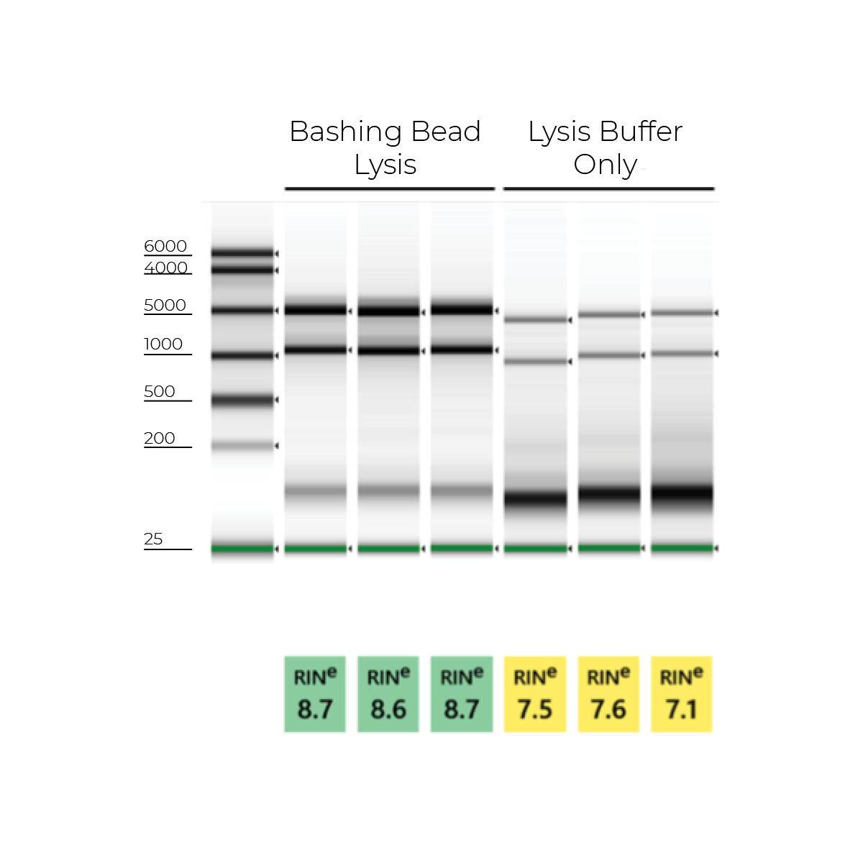Figure 1: Total RNA extracted from E. coli cells collected in lysis buffer and mechanically homogenized with bashing beads (samples 1-3) vs extraction with the lysis buffer alone (samples 4-6). Mechanical homogenization in lysis buffer yields robust 23S/16S ribosomal bands and higher ribosomal integrity numbers (RIN). Agilent 2200 TapeStation®.
Furthermore, it is important to note that complete sample lysis also helps the extraction procedure run smoothly. Incomplete lysis with column-based extraction methods can cause column clogging, buffer carryover, DNA contamination, and incomplete elution. With all of this in mind, Zymo Research has gone to great lengths to optimize the most efficient lysis regimens for all common sample types.

HOW TO ELIMINATE DNA CONTAMINATION
Another common problem associated with RNA extraction is DNA contamination. The presence of DNA can skew UV/VIS based quantification methods (e.g. Nanodrop), artificially increasing the RNA quantification higher than what it really is. Plus, it can also result in false readings in more sensitive downstream applications (e.g. RNA-seq). To ensure that you are getting the most accurate quantification measurements and to avoid any discrepancies in downstream analysis, it is important to eliminate any DNA carryover. This can be done in a variety of ways (e.g. TRIzol® phase separation, DNA removal columns, and DNase treatment).
The fastest method for confirming the presence of DNA is to visualize the RNA samples (e.g. agarose gel, Agilent TapeStation®, etc.) and look for any high molecular weight fragments above the 28S ribosomal RNA band (Figure 2). Other methods, such as qPCR or Qubit, can also be used and are preferable if you are performing downstream applications with sensitivity to DNA contamination.
Zymo Research has developed its RNA extraction kits with novel buffer and columns systems that bind and extract RNA while eliminating contaminating DNA. In comparison, many other products on the market are co-purification based, and thus retain high levels of DNA contamination. As an added value, the best RNA isolation kits include a DNase I set for on-column treatment. This removes the need for a post-extraction DNase treatment and clean-up steps as well as streamlines the process from extraction to downstream application. Figure 3 below illustrates how effective the Zymo on-column DNase treatment is based on the lack of DNA amplification via PCR.
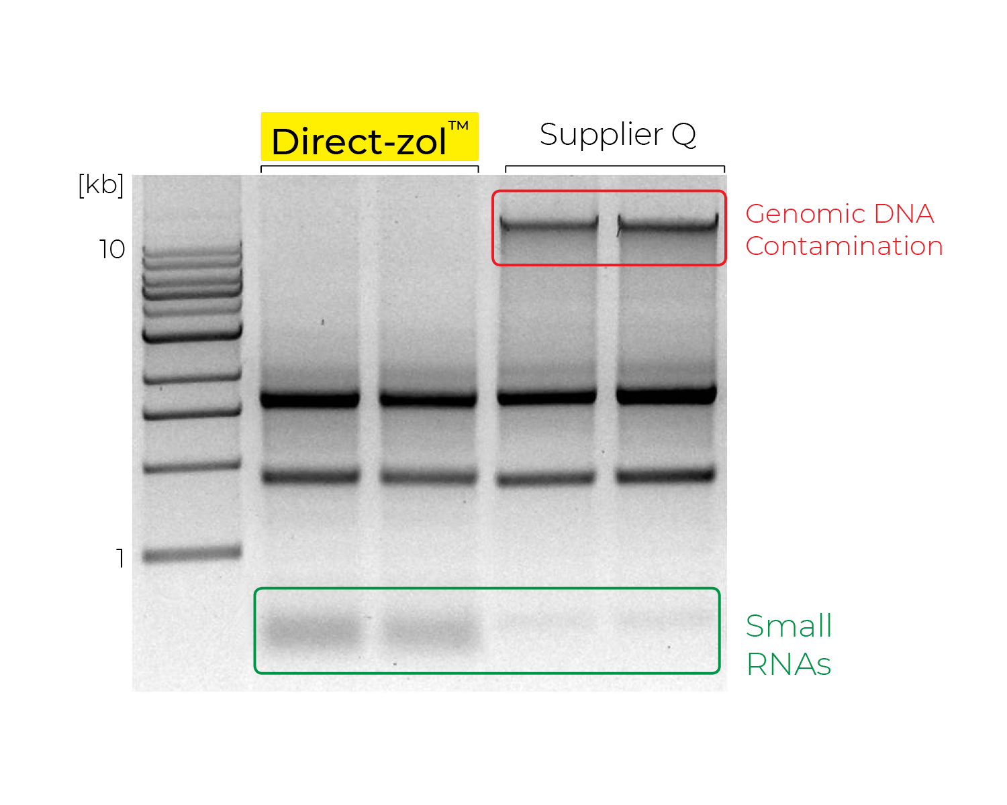Figure 2: RNA profiles from human epithelial cells visualized using agarose gel electrophoreses. The RNA extracted using a Zymo Research kit is free of contaminating genomic DNA and has a higher recovery of small RNAs compared to Supplier Q and Supplier P.

